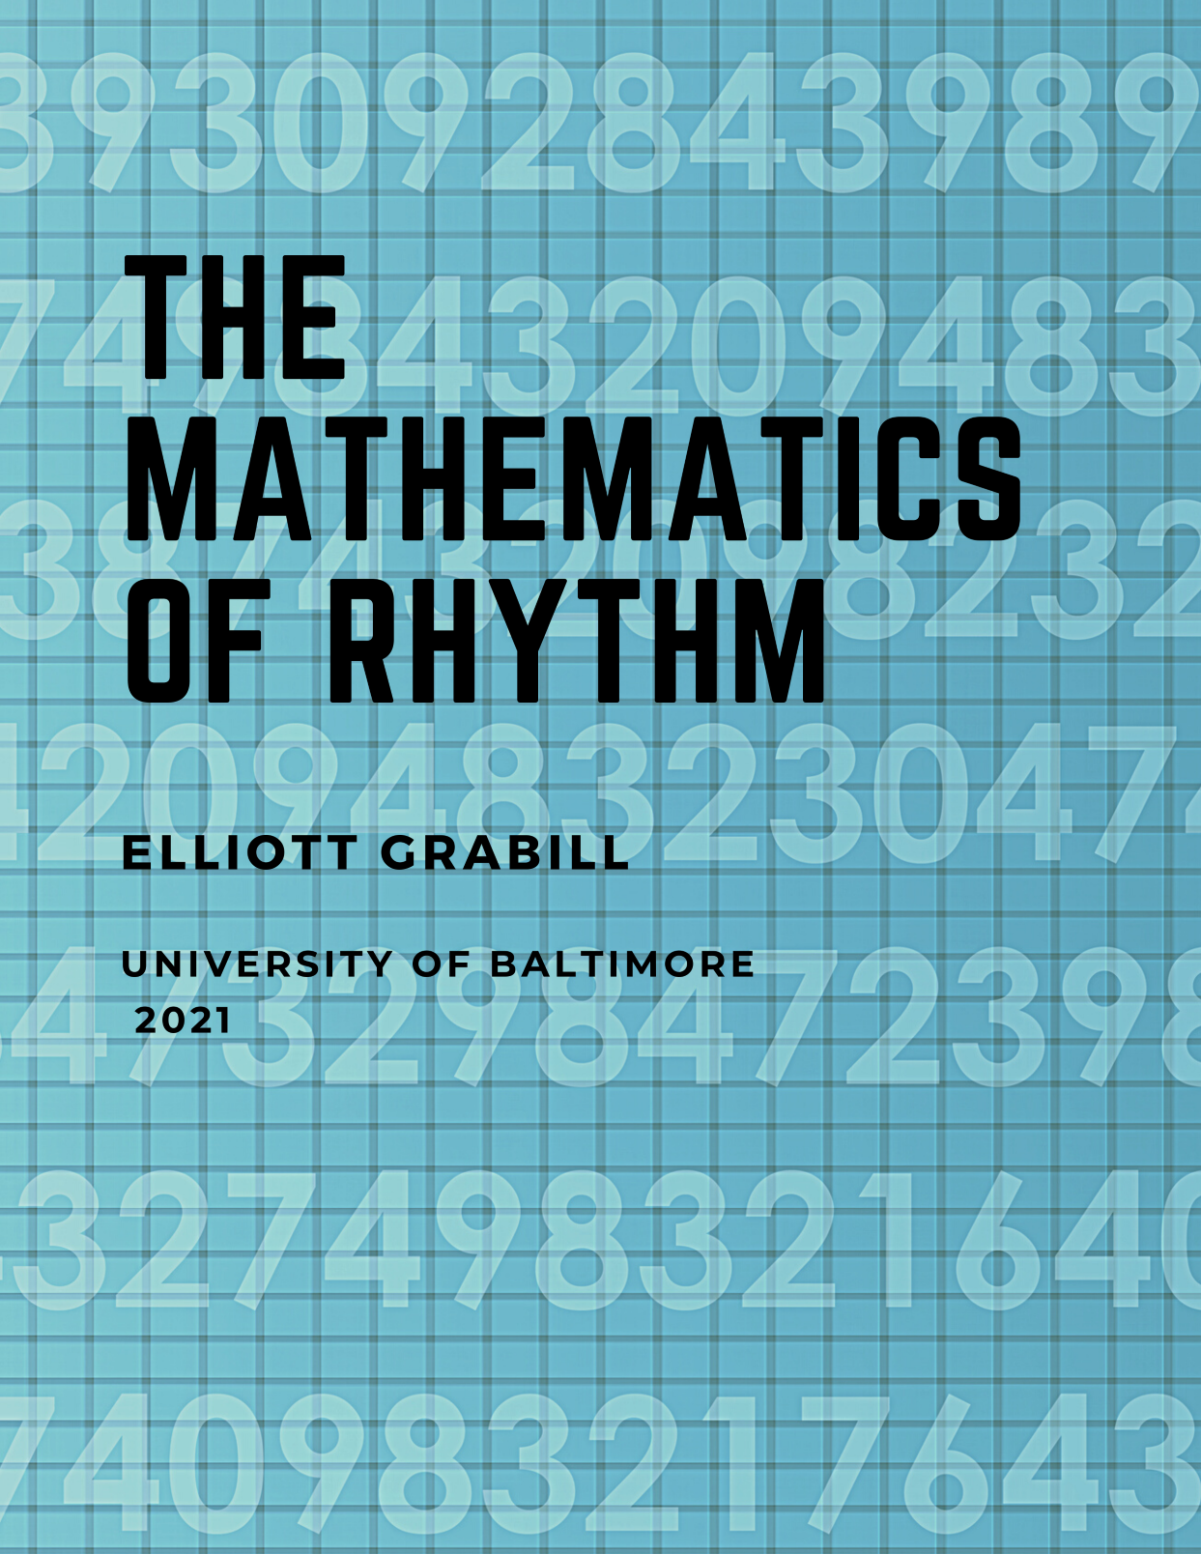

The Mathematics of Rhythm

The Mathematics of Rhythm

Music & Math Using Supercollider

Elliott Grabill

The Mathematics of Rhythm by Elliott Grabill is licensed under a Creative Commons Attribution-NonCommercial-ShareAlike 4.0 International License, except where otherwise noted.

Contents
- The Mathematics of Rhythm
- Appendix A: Diagram of Western Musical Notation
Kristin Conlin
- Appendix B: Diagram of Western Musical Notation Rests
- Appendix C: Latin Rhythms
- Works Cited

Chapter 1

The Mathematics of Rhythm

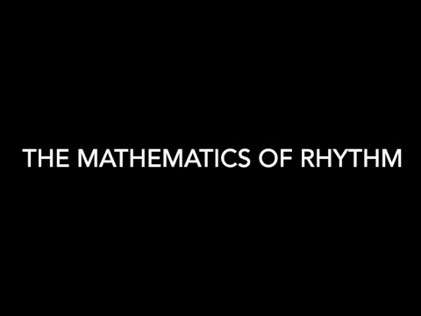
A YouTube element has been excluded from this version of the text. You can view it online here: https://ubalt.pressbooks.pub/musicandmathsupercollider/?p=39
The above video contains a demonstration for setting up and playing music on SuperCollider.
First, download this Rhythm Lesson Worksheet.
Then, download SuperCollider: https://supercollider.github.io/download
After you download the Rhythm Lesson Worksheet and SuperCollider, you will also need to download the instrument files linked below.
Tom
Bass Drum
Cowbell 1
Cowbell 2
Tambourine
Snare
Copy and paste the text below into a blank SuperCollider document. Replace all of the lines starting with “/Users/elliottgrabill/Documents…” by clicking and dragging the downloaded audio files (as shown in the above video demonstration).
//HIGHLIGHT “s.boot” and press SHIFT + ENTER. s.boot;
//DOUBLE CLICK to the right of the “(” below. Press SHIFT + ENTER.
(
//Tom
= Buffer.read(s, “/Users/elliottgrabill/Documents/Paper Documents/Math/OER Files/Tom.wav”
);
//Bass Drum
= Buffer.read(s, “/Users/elliottgrabill/Documents/Paper Documents/Math/OER AudioFiles/Bass Drum.wav”
);
// Cowbell 1
= Buffer.read(s, “/Users/elliottgrabill/Documents/Paper Documents/Math/OER Files/Cowbell
1.wav”
);
// Cowbell 2
= Buffer.read(s, “/Users/elliottgrabill/Documents/Paper Documents/Math/OER AudioFiles/Cowbell 2.wav”
);
//Tambourine
= Buffer.read(s, “/Users/elliottgrabill/Documents/Paper Documents/Math/OERFiles/Tambourine.wav”
);
// Snare
= Buffer.read(s, “/Users/elliottgrabill/Documents/Paper Documents/Math/OER AudioFiles/Snare.wav”
);
SynthDef(“normal”, {
arg amp = 1, bufnum = 0, rate = 1.066666667, loop = 0, ffreq = 1000, rel = 10; var snd;
var env = Env.new([0, 5, 1, 0], [0.01, 16, 6],[-5, 0, 3]);
var envgen = EnvGen.ar(env, doneAction: 2);
snd = PlayBuf.ar( numChannels: 2, bufnum: bufnum, rate: rate, loop: loop ) * envgen * amp;
Out.ar([0, 1], snd);
}
).add;
~mySynth = Synth(“normal”, [\bufnum, a, \amp, 0.1, \rel, 10]);
)
// EXAMPLE 1
~drum = Pbind(
\instrument, “normal”,
\bufnum, a,
\dur, Pseq([
1, 0.33333, 0.33333, 0.33333, 1, 2,
1, 2
], 15),
\rate, 1
).play;
// EXAMPLE 2
~drum = Pbind(
\instrument, “normal”,
\bufnum, a,
\dur, Pseq([
2, 2, // MEASURE 1
0.5, 0.5, 2.5, 0.5 // MEASURE 2
], 15),
\rate, 1
).play;
// EXAMPLE 3
// TWO RHYTHMS AT THE SAME TIME
t = TempoClock(144/60);
{
~tambourine = Pbind(
\instrument, “normal”,
\bufnum, e,
\dur, Pseq([
1, 0.33333, 0.33333, 0.33333, 1, 2,
1, 2
], 5),
\rate, 1
).play(t);
~drum = Pbind(
\instrument, “normal”,
\bufnum, c,
\dur, Pseq([
1.5, 2.5,
1.5, 2.5
], 5),
\rate, 1
).play(t);
}.fork(t);
// EXAMPLE 4
// cCHANGING THE TEMPO
t = TempoClock(144/60);
{
~tambourine = Pbind(
\instrument, “normal”,
\bufnum, e,
\dur, Pseq([
1, 1, 0.5, 1,
0.5, 0.5, 0.5, 0.5, 0.5
], 5),
\rate, 1
).play(t);
~drum = Pbind(
\instrument, “normal”,
\bufnum, c,
\dur, Pseq([
1.5, 1.5,
1.5, 1.5
], 5),
\rate, 1
).play(t);
}.fork(t);

1

Appendix A: Diagram of Western Musical Notation

Kristin Conlin
Name | Symbol | Duration | May also look like: | Comments
Whole note |  | 4
Dotted half note |  | 3
Half note |  | 2
Dotted quarter note |  | 1.5
Quarter note |  | 1
Dotted eighth (8th) note |  | 0.75 |  | Dotted 8th note + 16th note
Eighth note (8th) |  | 0.5 |  | Two 8th notes
Triplet eighth (8th) note |  | .33333 |  | Three triplet 8th notes
Sixteenth (16th) note |  | 0.25 |  | Four 16th notes
Thirty-second (32nd) note |  | 0.125 |  | Four 32nd notes

2

Appendix B: Diagram of Western Musical Notation Rests
Name | Symbol | Duration
Whole rest |  | 4
Dotted half rest |  | 3
Half rest |  | 2
Dotted quarter rest |  | 1.5
Quarter rest |  | 1
Dotted eighth (8th) rest |  | 0.75
Eighth (8th) rest |  | 0.5
Triplet eighth (8th) rest |  | 0.33333
Dotted sixteenth (16th) rest |  | 0.25
Thirty-second (32nd) rest |  | 0.125

3

Appendix C: Latin Rhythms
s.boot;
(
//Tom
a = Buffer.read(s, “/Users/elliottgrabill/Documents/Paper Documents/Math/OER Files/Tom.wav”
);
//Bass Drum
b = Buffer.read(s, “/Users/elliottgrabill/Documents/Paper Documents/Math/OER Audio Files/Bass Drum.wav”
);
// Cowbell 1
c = Buffer.read(s, “/Users/elliottgrabill/Documents/Paper Documents/Math/OER Audio Files/Cowbell 1.wav”
);
// Cowbell 2
d = Buffer.read(s, “/Users/elliottgrabill/Documents/Paper Documents/Math/OER Audio Files/Cowbell 2.wav”
);
//Tambourine
e = Buffer.read(s, “/Users/elliottgrabill/Documents/Paper Documents/Math/OER Audio Files/Tambourine.wav”
);
// Snare
f = Buffer.read(s, “/Users/elliottgrabill/Documents/Paper Documents/Math/OER Audio Files/Snare.wav”
);
SynthDef(“normal”, {
arg amp = 1, bufnum = 0, rate = 1.066666667, loop = 0, ffreq = 1000, rel = 10;
var snd;
var env = Env.new([0, 5, 1, 0], [0.01, 16, 6],[-5, 0, 3]);
var envgen = EnvGen.ar(env, doneAction: 2);
snd = PlayBuf.ar(
numChannels: 2,
bufnum: bufnum,
rate: rate,
loop: loop
) * envgen * amp;
Out.ar([0, 1], snd);
}
).add;
~mySynth = Synth(“normal”, [\bufnum, a, \amp, 0.1, \rel, 10]);
)
// EXAMPLE 1
// SIMPLE
~drum = Pbind(
\instrument, “normal”,
\bufnum, a,
\dur, Pseq([
1, 1, 0.5, 0.5, 1,
2, 1, 1
], 15),
\rate, 1
).play;
// EXAMPLE 2
// CHA CHA
t = TempoClock(120/60);
{
~cowbell = Pbind(
\instrument, “normal”,
\bufnum, e,
\dur, Pseq([
1, 1, 1, 1
], 5),
\rate, 1
).play(t);
~drum = Pbind(
\instrument, “normal”,
\bufnum, c,
\dur, Pseq([
1, 0.5, 0.5, 1, 0.5, 0.5
], 5),
\rate, 1
).play(t);
}.fork(t);
// EXAMPLE 3
// RUMBA
t = TempoClock(184/60);
{
~cowbell = Pbind(
\instrument, “normal”,
\bufnum, e,
\dur, Pseq([
1, 0.5, 1, 1, 0.5,
1, 1, 0.5, 1, 0.5
], 5),
\rate, 1
).play(t);
~drum = Pbind(
\instrument, “normal”,
\bufnum, c,
\dur, Pseq([
1.5, 2, 1.5,
1, 2
], 5),
\rate, 1
).play(t);
~bassdrum = Pbind(
\instrument, “normal”,
\bufnum, b,
\dur, Pseq([
1.5, 2.5,
4
], 5),
\rate, 1
).play(t);
}.fork(t);
// EXAMPLE 4
// MAMBO
t = TempoClock(184/60);
{
~cowbell = Pbind(
\instrument, “normal”,
\bufnum, e,
\dur, Pseq([
1, 0.5, 1, 0.5, 0.5, 0.5,
1, 1, 0.5, 1, 0.5
], 5),
\rate, 1
).play(t);
~drum = Pbind(
\instrument, “normal”,
\bufnum, c,
\dur, Pseq([
1.5, 1.5, 2,
1, 2
], 5),
\rate, 1
).play(t);
~bassdrum = Pbind(
\instrument, “normal”,
\bufnum, b,
\dur, Pseq([
1.5, 1.5, 2.5,
1.5, 1,
], 5),
\rate, 1
).play(t);
}.fork(t);
// EXAMPLE 5
// NEW YORK MOZAMBIQUE
t = TempoClock(184/60);
{
~tambourine = Pbind(
\instrument, “normal”,
\bufnum, e,
\dur, Pseq([
1, 1, 0.5, 1, 1,
0.5, 1, 0.5, 1, 0.5
], 5),
\rate, 1
).play(t);
~drum = Pbind(
\instrument, “normal”,
\bufnum, c,
\dur, Pseq([
3.5, 2,
1.5, 1
], 5),
\rate, 1
).play(t);
~bassdrum = Pbind(
\instrument, “normal”,
\bufnum, b,
\dur, Pseq([
7.5, 0.5
], 5),
\rate, 1
).play(t);
}.fork(t);
// EXAMPLE 6
// SONGO
t = TempoClock(144/60);
{
~tambourine = Pbind(
\instrument, “normal”,
\bufnum, e,
\dur, Pseq([
1, 0.5, 0.5, 0.5, 0.5, 0.5, 0.5
], 5),
\rate, 1
).play(t);
~drum = Pbind(
\instrument, “normal”,
\bufnum, c,
\dur, Pseq([
1, 1.5, 1, 0.5
], 5),
\rate, 1
).play(t);
~bassdrum = Pbind(
\instrument, “normal”,
\bufnum, b,
\dur, Pseq([
1.5, 1.5, 1
], 5),
\rate, 1
).play(t);
}.fork(t);
// EXAMPLE 7
// NANIGO
t = TempoClock(144/60);
{
~tambourine = Pbind(
\instrument, “normal”,
\bufnum, e,
\dur, Pseq([
1, 1, 0.5, 1,
0.5, 0.5, 0.5, 0.5, 0.5
], 5),
\rate, 1
).play(t);
~drum = Pbind(
\instrument, “normal”,
\bufnum, c,
\dur, Pseq([
1.5, 1.5,
1.5, 1.5
], 5),
\rate, 1
).play(t);
}.fork(t);
// EXAMPLE 8
// MOZAMBIQUE
t = TempoClock(184/60);
{
~tambourine = Pbind(
\instrument, “normal”,
\bufnum, e,
\dur, Pseq([
1, 1, 0.5, 1, 1,
0.5, 1, 0.5, 1, 0.5
], 5),
\rate, 1
).play(t);
~cowbell1 = Pbind(
\instrument, “normal”,
\bufnum, d,
\dur, Pseq([
1.5, 1.5, 2.5,
1.5, 1
], 5),
\rate, 1
).play(t);
~cowbell2 = Pbind(
\instrument, “normal”,
\bufnum, c,
\dur, Pseq([
2, 4,
2
], 5),
\rate, 1
).play(t);
~bassdrum = Pbind(
\instrument, “normal”,
\bufnum, b,
\dur, Pseq([
2, 4,
2
], 5),
\rate, 1
).play(t);
}.fork(t);
// EXAMPLE 8
// SALSA
t = TempoClock(108/60);
{
~tambourine = Pbind(
\instrument, “normal”,
\bufnum, e,
\dur, Pseq([
0.5, 0.5, 0.25, 0.5, 0.25,
0.5, 0.25, 0.5, 0.25, 0.25, 0.25
], 5),
\rate, 1
).play(t);
~drum = Pbind(
\instrument, “normal”,
\bufnum, c,
\dur, Pseq([
0.5, 0.5, 1,
0.75, 0.75, 0.5
], 5),
\rate, 1
).play(t);
~bassdrum = Pbind(
\instrument, “normal”,
\bufnum, b,
\dur, Pseq([
0.75, 2, 0.75, 0.5
], 5),
\rate, 1
).play(t);
}.fork(t);
// EXAMPLE 9
// SAMBA
t = TempoClock(182/60);
{
~tambourine = Pbind(
\instrument, “normal”,
\bufnum, e,
\dur, Pseq([
0.5, 0.5, 0.5, 0.5, 0.5, 0.5, 0.5, 0.5,
0.5, 0.5, 0.5, 0.5, 0.5, 0.5, 0.5, 0.5
], 5),
\rate, 1
).play(t);
~cowbell = Pbind(
\instrument, “normal”,
\bufnum, c,
\dur, Pseq([
1, 1.5, 1, 1,
1, 0.5, 1, 1
], 5),
\rate, 1
).play(t);
~bassdrum = Pbind(
\instrument, “normal”,
\bufnum, b,
\dur, Pseq([
1.5, 0.5, 1.5, 0.5,
1.5, 0.5, 1.5, 0.5
], 5),
\rate, 1
).play(t);
}.fork(t);
// EXAMPLE 10
// BOSSA NOVA
t = TempoClock(182/60);
{
~tambourine = Pbind(
\instrument, “normal”,
\bufnum, e,
\dur, Pseq([
1, 1, 1, 1,
1, 1, 1, 1
], 5),
\rate, 1
).play(t);
~cowbell = Pbind(
\instrument, “normal”,
\bufnum, c,
\dur, Pseq([
1.5, 1.5, 2,
1.5, 1.5
], 5),
\rate, 1
).play(t);
~bassdrum = Pbind(
\instrument, “normal”,
\bufnum, b,
\dur, Pseq([
1.5, 0.5, 1.5, 0.5,
1.5, 0.5, 1.5, 0.5
], 5),
\rate, 1
).play(t);
}.fork(t);
// EXAMPLE 11
// BAIAO
t = TempoClock(182/60);
{
~tambourine = Pbind(
\instrument, “normal”,
\bufnum, e,
\dur, Pseq([
1.5, 0.5, 1.5, 0.5,
1.5, 0.5, 1.5, 0.5
], 5),
\rate, 1
).play(t);
~cowbell = Pbind(
\instrument, “normal”,
\bufnum, c,
\dur, Pseq([
0.5, 0.5, 1.5, 0.5, 1.5,
0.5, 2, 1
], 5),
\rate, 1
).play(t);
~bassdrum = Pbind(
\instrument, “normal”,
\bufnum, b,
\dur, Pseq([
1.5, 1.5, 1,
1.5, 1.5, 1
], 5),
\rate, 1
).play(t);
}.fork(t);
// EXAMPLE 12
// PARTIDO ALTO
t = TempoClock(108/60);
{
~tambourine = Pbind(
\instrument, “normal”,
\bufnum, e,
\dur, Pseq([
0.5, 1.5, 0.5, 0.5, 1,
1, 1, 0.5, 0.5, 1
], 5),
\rate, 1
).play(t);
~cowbell = Pbind(
\instrument, “normal”,
\bufnum, c,
\dur, Pseq([
1, 3.5,
2.5, 1
], 5),
\rate, 1
).play(t);
~bassdrum = Pbind(
\instrument, “normal”,
\bufnum, b,
\dur, Pseq([
2.5, 1, 2.5,
1, 1
], 5),
\rate, 1
).play(t);
}.fork(t);
// EXAMPLE 13
// BATUCADA
t = TempoClock(182/60);
{
~tambourine = Pbind(
\instrument, “normal”,
\bufnum, a,
\dur, Pseq([
1, 2, 2,
2, 1
], 5),
\rate, 1
).play(t);
~cowbell1 = Pbind(
\instrument, “normal”,
\bufnum, b,
\dur, Pseq([
1.5, 0.5, 1.5, 0.5,
1.5, 0.5, 1.5, 0.5
], 5),
\rate, 1
).play(t);
~cowbell2 = Pbind(
\instrument, “normal”,
\bufnum, c,
\dur, Pseq([
2, 1.5, 1,
1, 0.5, 2
], 5),
\rate, 1
).play(t);
~cowbell2 = Pbind(
\instrument, “normal”,
\bufnum, e,
\dur, Pseq([
0.5, 0.5, 0.5, 1, 0.5, 0.5, 0.5,
0.5, 0.5, 0.5, 1, 0.5, 0.5, 0.5,
], 5),
\rate, 1
).play(t);
}.fork(t);
// EXAMPLE 14
// BEGUINE
t = TempoClock(144/60);
{
~snare = Pbind(
\instrument, “normal”,
\bufnum, f,
\dur, Pseq([
0.5, 1, 1, 1, 0.5
], 5),
\rate, 1
).play(t);
~bassdrum = Pbind(
\instrument, “normal”,
\bufnum, b,
\dur, Pseq([
2, 1, 1
], 5),
\rate, 1
).play(t);
~tambourine = Pbind(
\instrument, “normal”,
\bufnum, e,
\dur, Pseq([
1, 1, 1, 1
], 5),
\rate, 1
).play(t);
}.fork(t);
// EXAMPLE 15
// TANGO
t = TempoClock(108/60);
{
~snare = Pbind(
\instrument, “normal”,
\bufnum, f,
\dur, Pseq([
1, 1, 1, 2,
1, 1, 1
], 5),
\rate, 1
).play(t);
~bassdrum = Pbind(
\instrument, “normal”,
\bufnum, b,
\dur, Pseq([
1, 1, 1, 1,
2, 1, 1
], 5),
\rate, 1
).play(t);
~tambourine = Pbind(
\instrument, “normal”,
\bufnum, e,
\dur, Pseq([
3.5, 0.25, 0.25, 3.5, 0.25, 0.25
], 5),
\rate, 1
).play(t);
}.fork(t);
// EXAMPLE 15
// BOLERO
t = TempoClock(96/60);
{
~snare = Pbind(
\instrument, “normal”,
\bufnum, f,
\dur, Pseq([
0.5, 0.166667, 0.166667, 0.166666,
0.5, 0.166667, 0.166667, 0.166666,
0.5, 0.5,
0.5, 0.166667, 0.166667, 0.166666,
0.5, 0.166667, 0.166667, 0.166666,
0.166667, 0.166667, 0.166666, 0.166667, 0.166667, 0.166666
], 5),
\rate, 1
).play(t);
}.fork(t);
// EXAMPLE 16
// REGGAE
t = TempoClock(120/60);
{
~tambourine = Pbind(
\instrument, “normal”,
\bufnum, e,
\dur, Pseq([
0.66667, 0.33333, 0.66667, 0.33333,
0.66667, 0.33333, 0.66667, 0.33333
], 5),
\rate, 1
).play(t);
2.wait;
~bassdrum = Pbind(
\instrument, “normal”,
\bufnum, b,
\dur, Pseq([
4
], 5),
\rate, 1
).play(t);
}.fork(t);

4

Works Cited
Mattingly, Rick.
. Milwaukee: Hal Leonard Corporation, 2006.
Roberts, Gareth E.
. Baltimore: Johns Hopkins University Press, 2016.
Ruviero, Bruno.
. Licensed under the Creative Commons Attribution-ShareAlike 4.0 International License, 2015 edition.

